Report from the Charlotte Vulnerability Index 2010

Vulnerability Index Background
February 22, 2010 – February 26, 2010, a groundbreaking study took place in Charlotte to learn more about the chronically homeless population in our community. The study was sponsored by the Charlotte Housing Authority and led by staff from Common Ground of New York City and the Urban Ministry Center of Charlotte, NC. A team of over 100 volunteers carried out the study, through assistance from a variety of partners, including Homeless Services Network, Mecklenburg County Sheriff Department, Mecklenburg County Community and Homeless Support Services, City of Charlotte Neighborhood & Business Services, Harvest Center, Nexus Church, Salvation Army Center of Hope, Men’s Shelter of Charlotte, Center for Community Transitions, Samaritan House, Clara’s House of Love, Substance Abuse Service Center, and the Veteran’s Administration.

The Vulnerability Index is a tool created by Common Ground, to determine which members of the homeless community are most vulnerable and should be prioritized for housing. The tool is based on research by Dr. Jim O’Connell, which determined what conditions place a homeless individual at a higher risk than others for dying if he/she remains on the streets. Charlotte was the 22nd city in which Common Ground applied the tool.

Over three days, teams of volunteers surveyed homeless individuals to create a name-by-name registry of the chronically homeless in Charlotte. In addition to systematically gathering the names, pictures, and dates of birth of individuals sleeping on the street and in shelters, the teams also captured data on their health status, institutional history (jail, prison, hospital, and military), length of homelessness, and, and previous housing situation. These data were collected through use of a 33-item questionnaire.

The vulnerability index met two goals. First, the study created a registry of chronically homeless individuals, providing information on how many people are chronically homeless and who they are.
Even more importantly, however, the index gathered information to determine which chronically homeless individuals are the most vulnerable, in hopes of targeting these individuals for housing and supportive services in an effort to reduce chronic homelessness.

How the Survey was Conducted

Over 100 community members from a variety of backgrounds volunteered to carry out the survey. All interested volunteers went through a two-hour training on Monday, February 22nd, 2010. At the training, each volunteer was placed on a team, generally with 2-3 other members and an identified team leader. Each team was given the responsibility of a specific site to interview homeless individuals (ex. Urban Ministry Center, Men’s Shelter of Charlotte, Mecklenburg County Jail). In addition, five teams were given 2-3 police districts to seek out homeless camps to interview inhabitants. Volunteers administered the survey over a three days period, from February 23rd until February 25th, beginning as early as 5 am and continuing as late as 9 pm.

For participating in the survey, homeless individuals were offered 2 bus passes or a $2 McDonald’s gift certificate. A list of participants was kept and checked, to limit individuals participating in the survey more than once.

Before volunteers administered the full 33-question survey, individuals were pre-screened to determine if they met the definition of chronic homelessness. Volunteers only surveyed those individuals who met the definition of chronic homelessness (see footnote 1).

Definition of Vulnerability
An individual was labeled as “vulnerable” if he/she had at least one condition associated with a higher risk of mortality if he/she remains homeless. These conditions were identified through the research of Dr. Jim O’Connell of Boston, MA and are as follows:

  - End Stage Renal Disease
  - History of Cold Weather Injuries
  - Liver Disease or Cirrhosis
  - HIV+/AIDS
  - Over 60 years old
  - Three of more emergency room visits in prior three months
  - Three or more ER or hospitalizations in prior year
  - Tri-morbid (mentally ill+ abusing substances+ medical problem)

Results

The vulnerability index identified 807 chronically homeless individuals. Previously, the community estimated that there were 500 chronically homeless individuals. While the study did not identify every chronically homeless individual in the community, the study was thorough and is believed to be a fairly complete picture of chronic homelessness in Charlotte.

Of the 807 identified chronically homeless, 388 (48%) were identified as vulnerable, meaning they had at least on health condition associated with a high mortality risk. This is a slightly higher percentage than the average of 42% in the other 21 communities that have administered the vulnerability index.

Demographics

Consistent across the nation, Charlotte’s chronically homeless population is overwhelmingly male. Of the total surveyed, 81% identified as male. For those determined to be vulnerable, the percentage is only slight lower, with 78% identified as male. The specific breakdown is listed below, both for the overall chronically homeless population, as well as the breakdown of the 388 vulnerable individuals.

 | Total # of Chronically  Homeless |  | Total # of Chronically  Homeless with Vulnerability
Male | 657 | 81.31% | 302 | 77.84%
Female | 146 | 18.07% | 83 | 21.39%
Trans | 1 | 0.12% | 1 | 0.26%
Undisclosed | 3 | 0.37% | 2 | 0.52%

Racial disparities are evident in the analysis of the data as well. Nearly three-quarters of the chronically homeless population identify as African-American. Caucasian is the next most common racial identity, with 17% of those surveyed selecting white as their race.

 | Total # of Chronically  Homeless |  | Total # of Chronically  Homeless with Vulnerability
Black/African-American | 594 | 73.51% | 272 | 70.10%
White/Caucasian | 139 | 17.20% | 76 | 19.59%
Latino/Latina | 14 | 1.73% | 7 | 1.80%
Asian | 2 | 0.25% | 1 | 0.26%
Native American | 15 | 1.86% | 9 | 2.32%
Mixed Race | 36 | 4.46% | 19 | 4.90%
Other | 8 | 0.99% | 4 | 1.03%

The vast majority (92%) of those interviewed were U.S. citizens. No one responded as undocumented, though 6% of respondents did not answer the question regarding citizenship.

 | Total # of Chronically  Homeless |  | Total # of Chronically  Homeless with Vulnerability
Citizen | 744 | 92.08% | 358 | 92.27%
Legal Resident | 16 | 1.98% | 7 | 1.80%
Unknown | 47 | 5.82% | 23 | 5.93%

Interview Locations

Teams of volunteers administered the survey at 11 sites, as well as an additional five teams visiting homeless tent camps and abandoned homes throughout the city.

Individuals interviewed at the Urban Ministry Center made up nearly half of the overall chronic homeless population. The Urban Ministry Center offers a daily meal, as well as other basic services such as showers, laundry, and mail assistance.

Interestingly, Mecklenburg County Jail was the site with the next highest number of identified chronically homeless individuals. Charlotte was the first city to interview homeless individuals in jail for the vulnerability index. Thanks to the incredible cooperation of the Mecklenburg County Jail staff, a team of volunteers and jail staff interviewed over 400 inmates at all four of Mecklenburg County Jail sites (Central, North, Annex, Work Release) who had identified a “homeless address”. Of those interviewed, 128 were identified as chronically homeless. This is more than the number of chronically homeless identified at the Men’s Shelter of Charlotte, which hosts 500 homeless men each evening. Chronically homeless individuals are often more likely to sleep outside, thus making them more vulnerable for arrest with crimes associated with homelessness, such as trespassing, public urination, and open container.
See below for the breakdown of where chronically homeless individuals were found:

Location | Total # of Chronically  Homeless |  | Total # of Chronically  Homeless with Vulnerability
Urban Ministry Center | 380 | 47.09% | 169 | 43.56%
Mecklenburg County Jail | 128 | 15.86% | 58 | 14.95%
Men's Shelter of Charlotte | 116 | 14.37% | 65 | 16.75%
Harvest Center | 52 | 6.44% | 18 | 4.64%
Salvation Army Women's Shelter | 31 | 3.84% | 21 | 5.41%
Homeless Camps | 27 | 3.35% | 19 | 4.90%
Nexus Ministries | 25 | 3.10% | 11 | 2.84%
Substance Abuse Service Center | 19 | 2.35% | 11 | 2.84%
Outdoor Meal Sites | 14 | 1.73% | 5 | 1.29%
Samaritan House | 6 | 0.74% | 6 | 1.55%
Other | 9 | 1.12% | 5 | 1.29%

While the Urban Ministry Center (UMC) had by the far the highest number of chronically homeless individuals, the individuals interviewed at UMC were less likely to be considered vulnerable than those interviewed at other locations. Each of the 6 chronically homeless individuals at Samaritan House were considered vulnerable, which is not surprising, given that Samaritan House provides respite care for homeless individuals released from the hospital. While homeless camps and the Salvation Army Women’s shelter, had only around 60 chronically homeless individuals in total, two-thirds of those individuals were found to be vulnerable.

% of those Interviewed Identified
as Vulnerable
Samaritan House | 100.00%
Homeless Camps | 70.37%
Salvation Army Women's Shelter | 67.74%
Substance Abuse Service Center | 57.89%
Men's Shelter of Charlotte | 56.03%
Other | 55.56%
Mecklenburg County Jail | 45.31%
Urban Ministry Center | 44.47%
Nexus Ministries | 44.00%
Outdoor Meal Sites | 35.71%
Harvest Center | 34.62%

Risk Indicators

Once again, 388 individuals interviewed were identified as vulnerable, meaning they had at least one condition identified with an increased risk of mortality. Put plainly, over 388 members of the community are at risk of dying on the streets or in the shelters. While over half of those individuals had just one risk factor, six individuals had five or more risk factors.

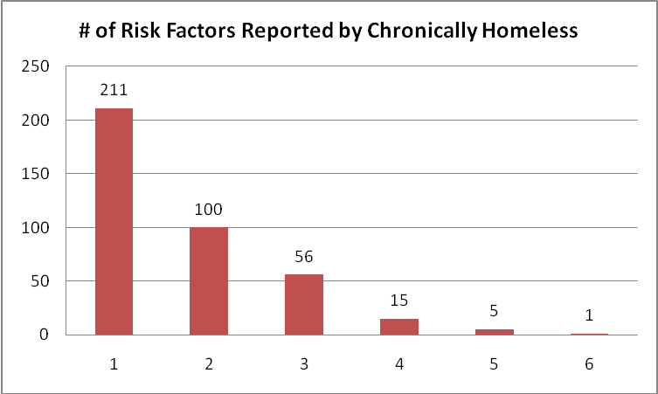

The most common risk factor was tri-morbidity, which is when an individual has a substance abuse problem, a mental illness, and a chronic physical health condition. Nearly a quarter of all individuals surveyed were considered tri-morbid. Frequent trips to the emergency room were the second most common risk factor, with 131 individuals visiting the ER three times or more in the past three months.

Risk indicator | Total # of Chronically  Homeless with condition | %
Tri-morbid | 186 | 23%
3x ER last 3 months | 131 | 16%
3x hospital last year | 61 | 8%
Liver Disease | 57 | 7%
> 60 years old | 54 | 7%
Cold/Wet Weather Injury | 53 | 7%
HIV+/AIDS | 41 | 5%
Kidney Disease | 31 | 4%
Length of Homelessness

The average length of homelessness for those surveyed was 5.2 years. For those considered vulnerable, the average was higher with an average of 6.1 years spent on the street or in shelters. The longest length of reported homelessness was 35 years – 2 respondents had experienced 35 years of homelessness.

Those who had a longer experience of homelessness were more likely to be considered vulnerable. Nearly 60% of the 100 individuals who had been homeless 10-20 years were considered vulnerable, while nearly three-quarters of the 34 people who were homeless 20 years or longer were vulnerable.

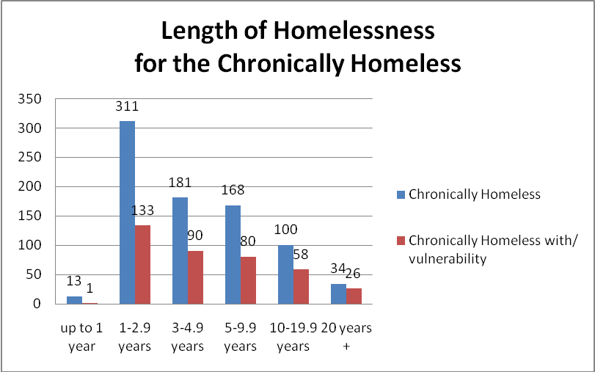

Age Breakdown

The survey identified 54 chronically homeless individuals age 60 or older. The oldest respondent was 68 years old. Twelve of these seniors reported being homeless longer than ten years. One senior reported a 25 year span of homelessness. This information is distressing given that there are at three subsidized housing complexes for seniors within uptown.

On the other end of the age spectrum, the survey identified 46 chronically homeless individuals age 25 or younger. The youngest age identified was 18, with two 18-year-old individuals meeting the definition of chronic homelessness. These 46 young adults had an average of 2.5 years on the street, though seven had been on the street five years or more. One young woman had been on the street almost 10 years.

Of the young adults, nearly 40% (18 people) had been in foster care. Other studies have recognized the link between young adult homelessness and a history in the foster care system. While only 14% of the total chronically homeless population had experience foster care, that percentage was almost triple for young adults.

Perhaps most alarmingly 11 of these young adults had at least one risk factor associated with increased risk of mortality. For young adults, research has identified a different set of three risk factors – injection drug use, HIV/AIDS, and daily intake of alcohol. Over a third of these vulnerable young adults were interviewed in Mecklenburg County Jail.

Veteran Status

Around 15% of those surveyed, 116 individuals, were veterans. Three-quarters of the veterans responded that they were honorably discharged, meaning that they are eligible for benefits from the Veteran’s Administration, which includes access to healthcare and limited housing benefits.

Of the 116 veterans, 61 met the criteria for vulnerability. Fifteen of those veterans considered vulnerable had been homeless 10 years or more. Seventeen of the vulnerable veterans were 60 years old or older.

Medical Health

Other studies have shown the tremendous public cost associated with treating the healthcare needs of the chronically homeless individuals, because they are more likely to receive their healthcare through frequent trips to the emergency room. The findings of this study corroborated previous findings.

Carolinas Medical Center’s (CMC) emergency room was by far the most common healthcare provider for those surveyed, with over 40% of the chronically homeless visiting the CMC ER when in need of medical care. Combined with those whose healthcare provider is Presbyterian Hospital’s emergency room, over half those surveyed use the emergency room for their primary place of medical care. CW Williams was the second most common healthcare provider, with 11% of respondents using this clinic as their healthcare provider. CW Williams has intentionally reached out to the homeless, running clinics several days a week at the Urban Ministry Center and Men’s Shelter of Charlotte, to ensure healthcare is easily accessible to the homeless. Almost 20% of those surveyed do not receive any form of healthcare.
PRIMARY HEALTHCARE PROVIDER | Total # of Chronically  Homeless |  | Total # of Chronically  Homeless with Vulnerability
CMC ER | 351 | 43.5% | 179 | 46.1%
CW Williams | 92 | 11.4% | 45 | 11.6%
Other | 80 | 9.9% | 44 | 11.3%
Presbyterian ER | 77 | 9.5% | 36 | 9.3%
CMC Myers Park | 47 | 5.8% | 31 | 8.0%
Does Not Go | 160 | 19.8% | 53 | 13.7%
Together, the 807 individuals interviewed are responsible for 1,157 visits to the ER in the last three months and 584 hospital admissions in the last year. Remarkably, 20 individuals are responsible for more than a quarter of the ER visits and 18% of the hospital admissions.

Using Carolinas Medical Center’s average cost of an emergency room visit ($1,029), these 807 individuals had a medical bill of nearly $1.2 million in the last three months alone. If assumed these individuals will continue the same pattern of hospital use over a year, the chronically homeless will have a medical bill of $4.7 million from emergency room visits over a year. Using the average cost of a hospital admission ($2,065), the total cost of the 584 hospital admissions reported by the chronically homeless was $1.2 million. Combined, these 807 individuals have an annual total hospital bill of $5.9 million.

The public cost of these frequent visits becomes more apparent when compared with the data on the health insurance held by the chronically homeless. Nearly three-quarters of those surveyed have no insurance, which means no Medicaid, Medicare, benefits from the VA, and no privately held insurance.

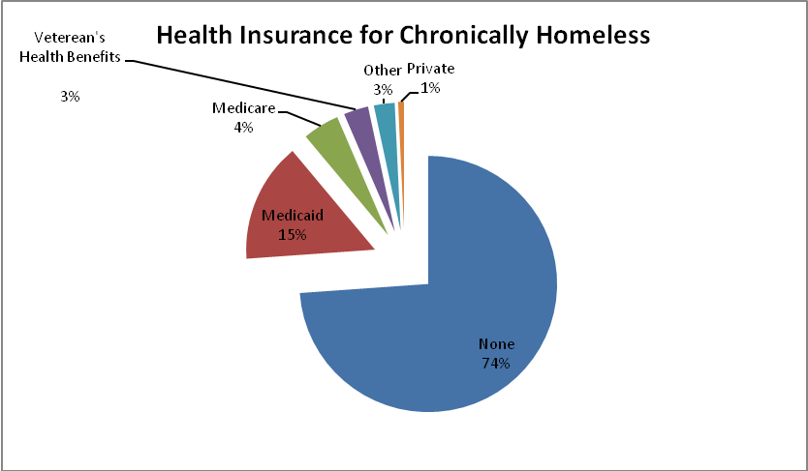
HEALTH INSURANCE* | Total # of Chronically  Homeless | Total # of Chronically  Homeless with Vulnerability
None | 594 | 256
Medicaid | 121 | 83
Medicare | 37 | 29
VA | 25 | 15
Other | 21 | 11
Private | 6 | 3
* Note: It is possible to have more than one form of insurance
Chronic illness was common among those surveyed. Beyond the previously reported numbers on HIV/AIDS, liver disease, and kidney disease, one-third of those surveyed (269 people) reported asthma, diabetes, or a heart condition. Twenty-three respondents had a history of cancer and 77 respondents had a history of Hepatitis C. Treatment for both diseases can be physically taxing and extremely difficult to receive if one does not have a stable place to rest and recuperate. Thirty-six individuals had a history of tuberculosis, a disease more common among the homeless, due to the communal living conditions of shelters.

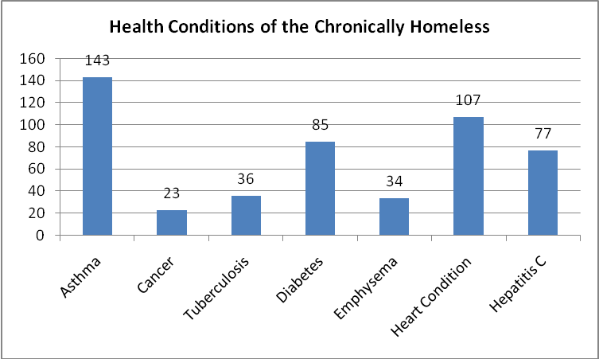

Over 20% of those interviewed, 166 individuals, had a brain injury or trauma that required hospitalization.

Behavioral Health

Mental illness and substance abuse were present with 679 of the identified chronically homeless individuals – 84% of those interviewed. The most common behavioral health issue was the combination of a mental illness with a substance abuse issue, commonly referred to as “dually-diagnosed.” Nearly 40% of the chronically homeless interviewed are considered “dually-diagnosed.” This statistic is noteworthy because individuals with both a mental illness and a substance abuse often struggle to participate in traditional treatment programs for either mental illness or substance abuse. Traditional substance abuse programs often prefer individuals are stabilized on medication before undergoing treatment and likewise, mental health providers prefer individuals achieve sobriety before treatment so mental health issues can be separated from the effects of drug and alcohol use.

Substance abuse was more common than mental health issues – 620 individuals, more than three-quarters of those interviewed, identified a substance abuse issue. Yet, mental illness issues were frequent. While the general estimate is that one-third of the homeless population has a mental illness, the percentage is higher for the chronically homeless. Of those surveyed, 46% were identified as having a mental health issue.

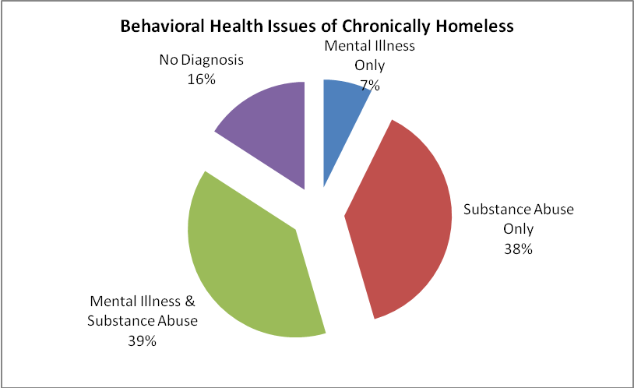

For those considered vulnerable, the prevalence of behavioral health issues was even higher. Almost 90% of those considered vulnerable had a behavioral health issue – substance abuse was reported for 85% of those considered vulnerable and mental health issues was reported for 63%. Once again, dual-diagnosis was the most common form of behavioral health issue with 57% of those considered vulnerable exhibiting dual-diagnosis.

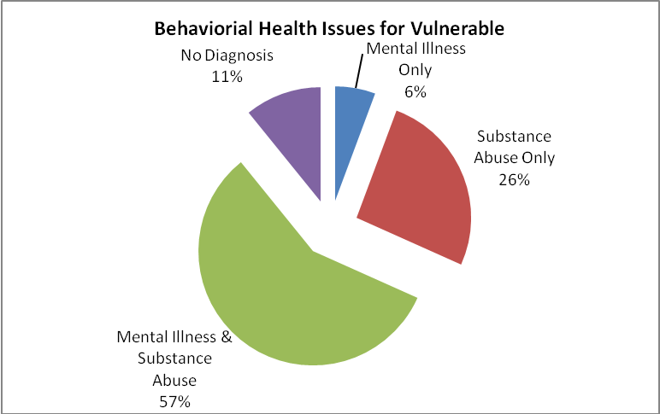

Jail and Prison
One of the major public costs associated with chronic homelessness is the cost of incarceration. Because chronically homeless individuals are more likely to live outside, they are also more susceptible to arrest for crimes associated with homelessness – such as trespassing, public urination, and open container. Mecklenburg County Sherriff’s Office 2007 study of chronic offenders found that 41% of Mecklenburg County’s most chronic offenders were homeless and most of their crimes were low level crimes associated with homelessness, such as trespassing.

This study found that incarceration was common among the chronically homeless. More than 84% of chronically homeless individuals had been to jail at least one time. A lower percentage, 48%, had spent time in prison. The Urban Ministry Center is doing further analysis to determine the nature of the charges associated with those surveyed.

Violence

The community was shaken when a homeless man was beaten to death outside a Statesville shelter in 2008, apparently in a random hate crime. The incident raised awareness about the physical dangers of being homeless.

Indeed, this study found that being the victim of violence was common among those experiencing long-term homelessness. Of those interviewed, 291 individuals (32%) reported being a victim of a violent attack since becoming homeless.

Sleeping Arrangements

The study found that shelters and streets are by far the most common places to find rest at night for the chronically homeless, with 466 chronically homeless individuals opting to sleep in shelters and 265 individuals opting for the streets. Given that Charlotte has less than 1,000 year-round shelter beds, the high numbers of chronically homeless individuals choosing shelters is significant.

A national study by (HUD) found that while chronically homeless individuals make up only 10% of the homeless population, they utilize nearly 50% of shelter beds. Such inefficiency can create a log jam in shelters, since chronically homeless individuals have a history of long-term homelessness and issues that can make it difficult for them to transition to traditional housing resources quickly. By contrast, 80% of single adults who utilize shelter stay for an average of just over a month. The overcrowding of shelters is an even greater issue in recent years, given the current economic conditions and the rising numbers of homelessness.

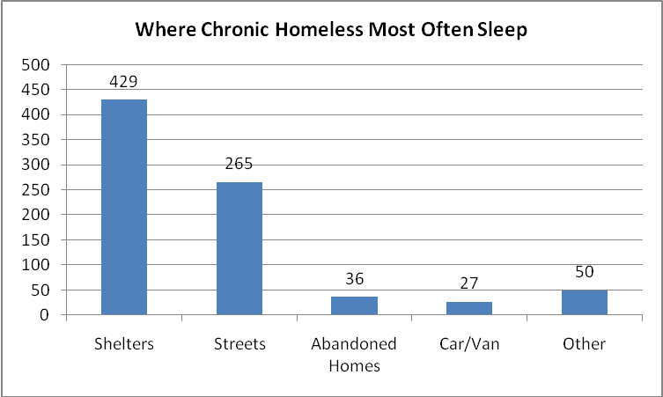

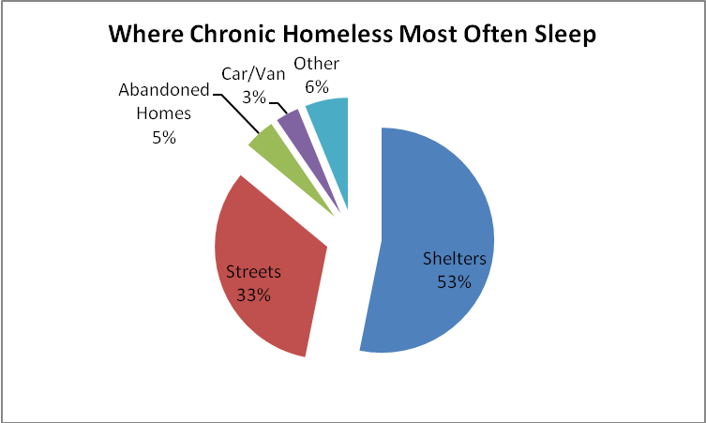

Income

A third of those surveyed reported they worked off the books, which was the most common source of cash income, followed by working on the books and panhandling. Despite the high rate of disabling conditions among the chronically homeless, only around 10% received a disability income check from the Social Security Administration or Veteran’s Administration.

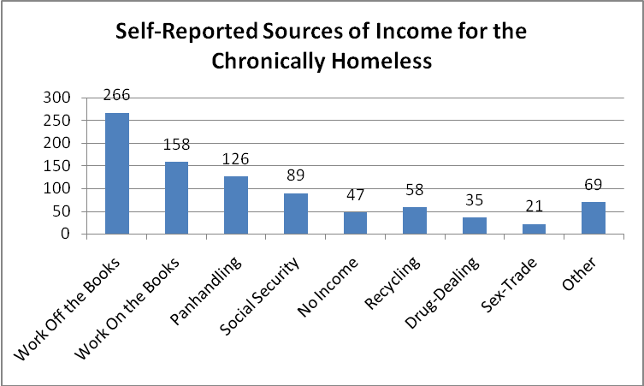
*Note: People could report more than one source of income

The most common economic resource for chronically homeless individuals was food stamps. Nearly half of those surveyed (47%) received food stamps. The amount of food stamps given is based on a person’s income, family size and expenses.

Prior Living

The survey asked where individuals lived prior to becoming homeless and found that more than half (57%) of respondents last had a stable home in Charlotte. An additional 10% had lived in the state or region before becoming homeless. Nearly 30% last had stable housing in a place outside of this region. It was not asked why people moved to Charlotte, though certainly anecdotally, Charlotte’s job market and specifically the construction market, has brought individuals seeking a better opportunity to the area.

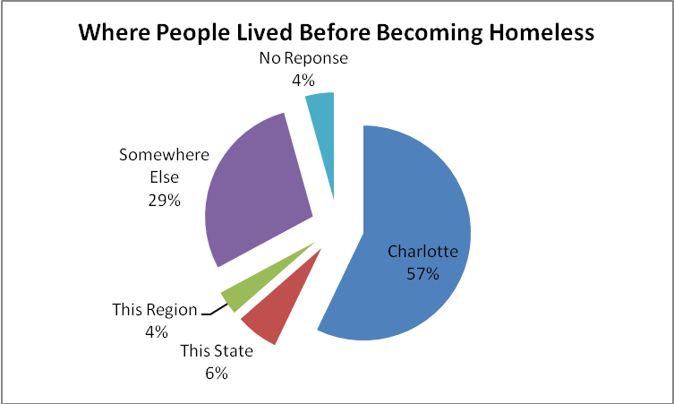

Trusted Person

In order to help located respondents after the survey was complete, to hopefully connect that individual with services and/or housing, the question was included: “Is there a person/outreach worker that you trust more than others?” Nearly 60% of those answered no, they do not have a person/outreach worker that is trusted more than others. For those who answered yes, a follow-up question was asked if that individual was connected to an agency. The breakdown of the agencies is as follows:

Agency of Trusted Individual | # of Respondents
Urban Ministry Center | 93
Men's Shelter of Charlotte | 56
Relatives/Friends | 23
Access/Mental Health Case Manager | 32
Homeless Support Services | 22
Salvation Army | 10
Harvest Center | 8
Nexus Ministries | 5
Mecklenburg County Jail | 4
Veteran's Administration | 3
Center for Community Transitions | 2
Church | 2
Crisis Assistance | 2
NA | 2
DSS | 2
Health Department | 2
RAIN | 2
Charlotte Rescue Mission | 2
Samaritan's House | 2
Other | 23

Conclusion

The purpose of the vulnerability index was not simply to gather information. The purpose of the vulnerability index was to gather information to end chronic homelessness, particularly for those indentified as vulnerable.

The Urban Ministry Center is working with other community agencies to connect those surveyed with limited existing resources as well as working to grow those resources to better meet the needs of those at risk of dying on Charlotte’s streets.

If you would like to join in the effort to end chronic homelessness, please contact the Urban Ministry Center through Kathy Izard, with the Homeless to Homes supportive housing program (kizard@carolina.rr.com) or Liz Clasen-Kelly, associate director (lclasen@urbanministrycenter.org).

This report was prepared by Liz Clasen-Kelly, Associate Director of the Urban Ministry Center, March 2010 with assistance from Common Ground.
Chronically homeless is defined by the Department of Housing & Urban Development as a single individual with a disabling condition that has been homeless for at least one year or four times in the last three years.
The mission of Common Ground is to end homelessness by transforming people, buildings, and communities. Founded in 1990, Common Ground rapidly grew to become the largest developer and manager of supportive housing in New York City, and has pioneered a new approach to outreach called Street to Home that is being replicated in cities across the country. Common Ground is currently organizing change agents to find and house the 100,000 most vulnerable homeless individuals in America as part of its 100,000 Homes Campaign.
Founded in 1994, the Urban Ministry Center is an interfaith organization that serves poor and homeless people with love and compassion and tangible help. Services include a soup kitchen; showers, restrooms and laundry facilities; phone and fax service; nurse and medical referrals; mail, paycheck, and prescription pick-up; food pantry and clothing referrals; assistance filing for disability and food stamps; Room in the Inn winter shelter program (December – March). www.urbanministrycenter.org
A homeless address is when an inmate reports his/her address as “homeless,” “unknown,” or any of the local shelters or service providers, such as the address of the Urban Ministry Center or Men’s Shelter of Charlotte.
Mental Illness was determined through 3 questions: “Are you currently or have you ever received treatment for mental health issues?”; “Have you ever been taken to the hospital against your will for mental health reasons?” and a question to the surveyor, “DO NOT ASK: Surveyor, do you detect signs or symptoms of severe, persistent mental illness?” A “yes” answer to any of the questions identified someone as having a mental illness.
Substance abuse was determined through 5 questions: “Have you ever abused drug/alcohol, or been told you do?”; “Have you consumed alcohol everyday for the past month?”; “Have you ever used injection drugs or shots?”; “Have you ever been treated for drug or alcohol abuse?”; and a question to the surveyor, “DO NOT ASK: Surveyor, do you observe signs of symptoms of alcohol or drug abuse?” A “yes” answer to any of the questions identified someone as having a substance abuse issue.
Kuhn, R. & Culhane, D.P. 1998. Applying cluster analysis to test of a typology of homelessness: Results from the analysis of administrative data. American Journal of Community Psychology, 17(1), 23-43.
Ibid.

