Mountain Island Lake Marine Commission
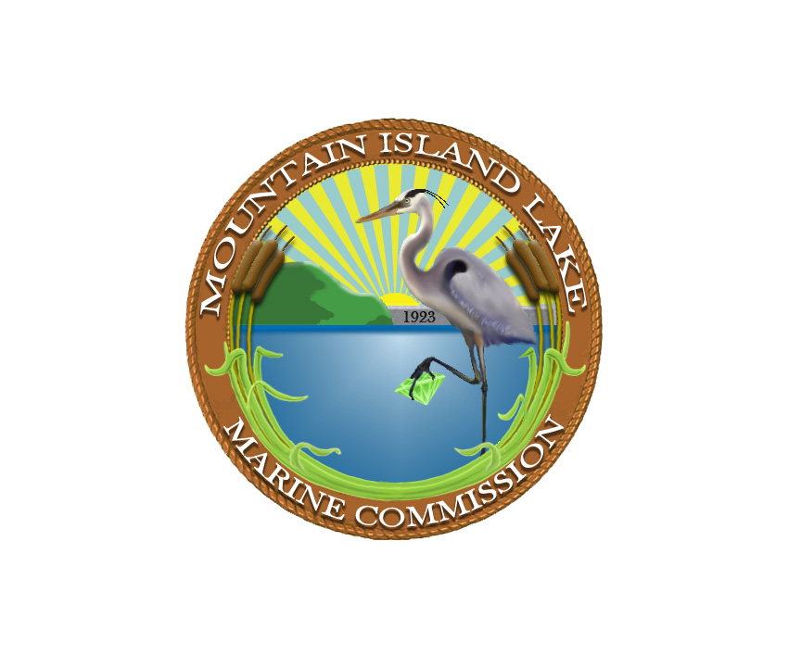
November 4, 2009
6:30 p.m.

Charlotte Mecklenburg Utilities
5100 Brookshire Blvd
Charlotte, NC

Minutes - REVISED
Commissioners Present: Chair Pam Beck (Gaston County), Vice Chair Alice Battle (Mecklenburg County), Secretary Treasurer Ann Danzi (Gaston County), Commissioner Skip Hudspeth (Mecklenburg County), Commissioner Craig Wyant (Lincoln County), Commissioner Tim Bishop (Mecklenburg County)
Commissioners Absent: Commissioner Tim Eldridge (Gaston County)
LWMC Staff Present: Annette Demeny, Executive Administrator, Chris Clark, Legal Counsel
Topic | Discussion Summary | Action
Welcome & Introductions | Chair Beck called the meeting to order at 6:37 pm. The Commissioners and Staff introduced themselves.
Approve Minutes – October 7, 2009 | The minutes from October 7, 2009 were approved. | Secretary Treasurer Danzi made a motion to approve the October 7, 2009 meeting minutes.  Seconded by  Commissioner Hudspeth. The motion was approved.
Approval of the November 4, 2009 Meeting Agenda | The November 4, 2009 meeting agenda was approved. | A motion was made by Vice Chairman Battle to approve the November 4, 2009 Agenda. Seconded by Commission Bishop. The motion was approved.
Consent Agenda | Consent Agenda – None
Public Comments | Public Comments – Bill Gupton, Chair for the Central Piedmont Group of the NC Chapter of the Sierra Club, commented on the Coal Ash problem on the Catawba River. Mr. Gupton stated that the issue of coal ash containment has been a silent issue with the general public for a long time until the event occurred at the TVA Kingston Fossil Plant in Tennessee. This event raised public awareness and citizens and environmental groups are now demanding of utilities such as Duke Energy and agencies such as the Mountain Island Lake Marine Commission to take action to assure the safety of our environment. Legal Counsel, Chris Clark suggested that Mr. Gupton send the Commission a bullet list of his recommendations to the Commission. Mr. Gupton agreed to forward this information and follow up with the Commission at a later date.
Stakeholder Reports  Stakeholder Reports (cont.) | Charlotte-Mecklenburg Police Dept Report – Officer Turner reported  Monthly Activity Report (October 2009)  - (10) Calls for Service  - (6) Zone Checks at Neck Rd Access  - (4) Zone Checks at Latta Plantation  - Participated in swim event at Latta Plantation  - Follow up on Graffiti on rock at Garr Creek: Unless there are derogatory drawings, wording or gang signs, the CMPD does not see a big problem with this situation.  Gaston County Sheriff’s Office – Officer Hord reported  - GCPD is off the lake except on an as needed basis.  Lincoln County Sheriff’s Office – No one was present to give report  N.C. Wildlife Resources – No one was present to give report  Mecklenburg County Parks and Recreation – No one was present to give report  Duke Energy – Kermitt Taylor reported  - (1) Pier Application Approved – Preservation Point  - (1) Shoreline Stabilization Application Approved – Stonewater  - Lake Level – 96.7
Environmental Reports  Environmental Reports (continued) | Mecklenburg County Land Use and Environmental Service Agency (LUESA) – Heather Davis reported  - LUSI (Lake Use Support Index) Results (September 2009) – Supporting+ results for all testing sites except for McDowell Creek (Supporting, 12 month average). High nutrients and high chlorophyll were found in this site. Most likely due to agriculture dumping. Will continue to monitor this area.  - November 21 – Planting trees at Henderson Park beginning at 9am.  Mountain Island Lake Lakekeeper – Alice Battle reported  - MI Wildlife Stewards attended the October 10th Covekeeper meeting to discuss having joint meetings. The Covekeepers have supported NC Wildlife efforts with fish attractors and Adopt-an-Island however, NC Wildlife have several projects that they are needing to follow up on and do not see having joint meetings with the Covekeepers necessary at this point. They do want to keep lines of communication open between the two groups and continue to work together.  - The 2010 animal is the Turtle. The basking platforms will be installed in March.  - Riverkeeper David Merryman reported at the October 10th meeting regarding the coal ash pond recommendations for Riverbend. There are standards for groundwater but not for surface water. The run-off from the ash ponds has not standards for heavy metal content. Mercury comes out of the smoke stacks; arsenic, boron, and selenium are some of the heavy metals found in coal ash. The Catawba Riverkeeper Foundation asked for reports on the four wells that monitor groundwater at the Riverbend site. As of October 10th, they have only received one report from one well and was dated 2008. The report showed the arsenic results just below the maximum for groundwater. CRF is advocating to have coal ash considered hazardous waste and for surface water standards to be set.  Regional Stormwater Partnership – Annette Demeny reported  - Tetra Tech (consulting firm out of Raleigh) conducted a workshop on October 27th on MS4 Audits and how to prepare for them. They will conduct another workshop on November 10th to discuss TMDL’s.  - Next meeting will be on November 13th to discuss grants and sustainability of the Partnership for next fiscal year.
Plant Allen Ash Pond Presentation  Plant Allen Ash Pond Presentation (continued) | Plant Allen Ash Pond Presentation – Pat McCabe, Duke Energy Environmental Health & Safety Group reported  Mr. McCabe began his presentation by stating that Duke Energy fully supports EPA in addressing Ash Basin Dyke Integrity. It’s an industry issue and should be resolved. Duke Energy has had a program in place for over 25 years that addresses Ash Basin Dyke Integrity. The reports that are generated from their testing are sent directly to DENR.  EPA recently reported that there are (49) forty-nine high hazard ash basin dykes identified in the Country. Out of these 49, Duke has (6) six of these facilities in the Carolinas. Since May, EPA has inspected each of these sites. Five reports have been generated from these site visits. Three (3) of the ash basins were rated Satisfactory, two (2) were rated Fair and one (1) is Pending. A Satisfactory rating is the highest rating on their scale which means that it is acceptable under all design conditions and no open issues.  Fly Ash is created when coal is burned and sent out in the emissions. Bottom Ash is the ash that remains inside of the boilers. There are two ways to manage ash; one way is called a wet handling system where they move the ash with water out to ash ponds. The second is dry handling system where the ash is blown over into silos. Up until 2009, Plant Allen used wet handling to disburse of the ash. Since June, Plant Allen has gone to mainly a dry ash system where the ash is stored in large silos to hopefully, be sold and reused in other markets.  To wrap up his presentation, Mr. McCabe educated the commission on groundwater. He informed the Commission that the pond that stores the ash at Plant Allen is not lined. To determine if having this pond not lined, would it cause any issues with contaminated groundwater. Duke Energy voluntarily installed nine wells in and around the Plant Allen Ash Basin in order to test the groundwater. Data has been collected from this wells since 2006 and the three noticeable issues were; Iron, Manganese and Boron. These three minerals exceeded the groundwater standards. However, this has only occurred on Duke Energy property. Duke Energy is working with DENR to determine what the next steps are. Duke plans on installing additional wells by 2010.  The Chairman opened the floor for questions.  Many questions were asked regarding groundwater monitoring and how long Duke has been conducting these tests. Duke monitors semi-annually and has monitored for about a year and a half. If the testing would come back above the legal standards, most likely the ponds would have to be drained and lined to prevent future problems. The reporting results are public information and are forwarded to DENR.  Voluntary wells – Duke installed monitoring wells but several comments from the public were questioning why Duke waited until 2008 to install them and are the testing sites adequate. Installations of these wells were based on scheduling by Duke. The exact age, size and depth of the ponds were not able to be provided. Mr. McCabe feels like the testing sites are adequate and are located in several key testing areas.  Safety concerns due to a potential catastrophic event. Duke replied that due to the location the current dyke ponds, if the pond should collapse, the damage that took place in Tennessee would not be possible here in Mountain Island Lake. If anything, only minimal release of ash would be disbursed into Mountain Island Lake.  The report given by Mr. McCabe was very informative and appreciated. Several questions from the public could not be answered by Duke therefore; Duke suggested that they follow up with them after the meeting so the necessary information could be provided to get their questions answered.
Base Operating Plan  Base Operating Plan (continued) | Base Operating Plan  - Blue Fin Award (Beck) – The 2009 Blue Fin Award will be presented at the January 2010 meeting.  - Post Boating Safety Rules (Battle) – Kiosks are scheduled to be delivered next week. Riverbend Access and Neck Road Access will be getting informational kiosks.  - Lake Management Plan (Battle) – Duke Energy commented on the results from the survey that was distributed in January 2008 to property owners around Mountain Island Lake. Duke feels that there is not enough hard data to support this plan. They suggest that the survey be generated to others such as; visitors to the lake. Vice Chairman Battle will get additional surveys and hand them out at the access areas. Duke also suggested that the Commission include the Mecklenburg Parks and Rec Department and the surrounding jurisdictions in the process of the Lake Management Plan.
Chairman’s Report | Chairman’s Report – Chair Pam Beck reported  - Chair Pam Beck distributed the revised Mountain Island Lake Advisory Board Resolution to the Commissioners. This Resolution lists the guidelines in order to participate on the Advisory Board. Upon approval, this resolution will be provided to the past Commissioners.  - The December 5th MILMC meeting will be at the Stonewater Clubhouse beginning at 6:30pm. There will be a brief business meeting and a holiday social following. | A motion was made by Secretary Treasurer Danzi to approve the revised Advisory Board Resolution as presented. Seconded by Vice Chairman Battle. The motion was approved.
Executive Administrator’s Report | Executive Administrator’s Report – Executive Administrator Annette Demeny reported  • Finance Report – the Finance Report was provided to the Commissioner’s prior to the business meeting. There were no questions regarding this information.  - MILake Map – As a follow up from a suggestion from Commissioner Wyant, Mrs. Demeny reported that Centralina Council of Governments could produce a large map of Mountain Island Lake to display the monthly MILMC meetings. This map would depict: topography, streams, conserved/protected land, buoys, no wake zones, boat access areas, watershed areas and water bodies. The cost would be approximately $680.00. Commissioner Wyant stated that he too will look into other sources to produce map. Will follow up with this suggestion at the first of the 2010 year.
Commission Counsel Report | Commission Counsel Report – No Report
Comments | Comments - None
Adjournment | There was no further business and the meeting was adjourned at 8:16 pm | A motion was made by Vice Chairman Battle to adjourn the November 4, 2009 business meeting. Seconded by Commissioner Hudspeth. The motion was approved.
Next Business Meeting Date and Location | The next LWMC business meeting will be held on January 6, 2010 beginning at 6:30pm at Cowan’s Ford Country Club, 761 Club Drive, Stanley, NC.

Annette Demeny, Executive Administrator

