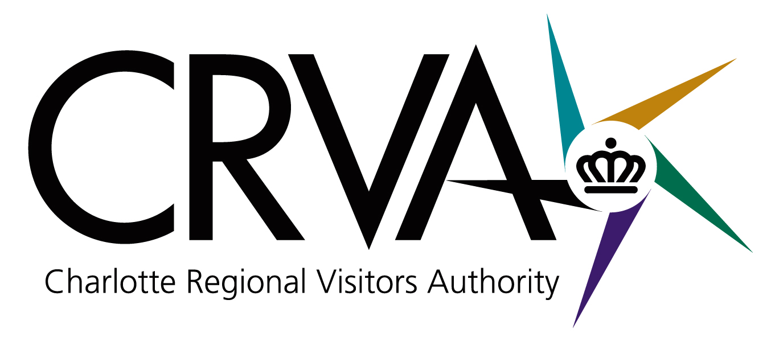

Charlotte Regional Visitors Authority
Board Meeting
Wednesday, April 11, 2012 – 8 AM
NASCAR Hall of Fame Legends Room

Attending: Joe Hallow, Vinay Patel, Rai Glover, Derick Close, Tom Sasser, Larry Huelsman, Paul Jamison, Chuck Allen, Russ Sizemore, and Will Miller. In attendance via teleconference: Geoff Durboraw and Mike McGuire. Mr. Manno had resigned from the board.

Staff in Attendance: Tom Murray; Mike Crum; Mike Butts; Gina Sheridan; Ted Lewis; Bob Buchanan; Winston Kelley; Larry Williams; Molly Hedrick; Mike Riviello; Jorge Roriguez; Nick Biancofiore; Jeff Mann; Kimberly Meesters; Kamin Brennan; Scott Angstman; Mariel Littrell and Debbie Aldridge.

Others in Attendance: Cameron Furr, CRVA Attorney from Grier Furr & Crisp; Ron Kimble, Deputy City Manager; Erik Spanberg from the Business Journal; Linzi Sheldon with Channel 9 News; Sid Smith representing Charlotte Area Hotel Association (CAHA); and Julie Rose from WFAE.

Meeting Called to Order: Chairman Hallow called the meeting to order with a special welcome back to Gina Sheridan from her maternity leave.

Approval of March 14, 2012 Meeting Minutes: Rai Glover made a motion to accept the minutes as submitted for March 2012. The motion was seconded by Mr. Close. For: Hallow, Patel, Glover, Sasser, Close, Huelsman, Jamison, Allen, Sizemore, Miller, Durboraw and McGuire. Against: None.

CRVA Reorganization Update: Mr. Murray began his presentation with a view of the roof work replacement being done at the Convention Center. The final cost of the project will be $4.2 million. The CRVA Executive Leadership Team met March 16-20 for a low-cost retreat at the Convention Center. The first phase of restructuring has been completed and mid-April the Executive Leadership Team will announce the 21 members of the Senior Leadership Team in the organization. There will be some efficiencies realized creating some cost savings. The next step will be for the Senior Leadership Team to finish the organizational chart by working closely with the Human Resource Department to work out changes in some staff positions. The Executive Leadership Team has been open to change and working together.

Baseball Stadium Proposal Update: Mr. Kimble was invited to give a status report on the uptown Baseball Stadium project. The Economic Development Committee (EDC) has been meeting with the Knights Baseball organization and the EDC is ready to propose how the City would enter into the equation of bringing the Knights Baseball to uptown Charlotte. There have been discussions on the economic impact as well as community impact for use of the baseball park for events other than baseball games (i.e., tournaments and non-profit organization use). The new baseball park would create North Carolina jobs and generate North Carolina taxes. The cost of constructing the stadium would be $54 million with the Knights responsible for all construction cost overruns. The county would provide the land and lease it to the Knights. The Knights would pay property taxes on the improvement to the land and pay property taxes on the market value of the underlying lease. Comparable minor league stadiums with public/private partnerships were reviewed. As of April 4, 2012, the Knights would provide $37 million in funding, the county investment would be $8 million with the City investing $9 million. The City funding would come from $4.5 million tourism funding and $4.5 million from an Economic Development Grant. The total stadium and land cost would be $74 million creating a 50/50 public/private partnership. The Knights have to build the stadium and play baseball in the stadium. If for any reason they discontinue playing baseball in the stadium, funds do not flow to the team. This protects the tax payers and tourism partners.

The tourism funding equals ten years of equal payments of $611,500 per year which yields $4.5 million net present value at a 6% discount rate. The source of funds is the first 3% occupancy tax for tourism. The first payment would be made after the stadium is built and the Knights are playing baseball uptown. The city’s payment is over eight years.

The other $4.5 million contribution would be covered by seven tax increment capture development pads surrounding the stadium site. It is projected that the sites will develop faster and denser with a new ballpark than they otherwise would. If the developments do occur, the City will flow back 90% of the property taxes to the Knights. The developments must happen and pay property taxes to the City before the 90% flow back to the Knights will occur. The Knights bear the risk of whether the sites surrounding the ball park stadium develop with the velocity, volume and value the Knights predict. It will take 18 months to construct the stadium. If litigation prevents completion of the baseball park, the Knights must pay the City’s legal costs.

Next steps: Staff goes back to the EDU on April 19th, to answer questions and then goes to Council on April 23rd or May 14th for a vote. The Baseball Stadium would need to be open by April 1, 2014. The Chamber of Commerce and the Charlotte Area Hotel Association are on record as supporting the project. Mr. Kimble expects the Hospitality & Tourism Association and the Center City Partners to do the same. He asked that the CRVA discuss this and decide if they wish to go on record in support of the project.

City Staff 2012 Capital Improvement Plan Recommendation: The Board was briefed by Mr. Crum on the Bojangles’ Amateur Sports Complex proposal in March which has also been introduced to the public through the Capital Investment Plan developed by City Staff. The City has developed a vision for what this area of the community should look like over the next ten years and applied this vision to focus areas for improvement using the City budget as a catalyst for the changes and for developing public and private partnerships emphasizing projects that have a long term impact on the community. The City believes that it needs to have a capital program to maintain the vitality of the community and is proposing a 4 cent property tax increase. Schematically, the investments fall into three categories: corridor investments, improvements in communities in need and investments in connections through road projects. The Bojangles’ project is a corridor investment project. Other sister projects include street improvements and neighborhood improvements to enhance the Independence Boulevard corridor. The Bojangles’ Coliseum project is a three phase project. Mr. Crum reviewed the distribution of capital funding for all projects with a total of $349.5 million in FY 2012 . The Bojangles project would be funded through the first referendum. Council has heard the recommendation and it will be considered for adoption with the June budget process.

If all goes as planned, the new Bojangles complex would be up and running in mid to late 2015. There would be a limited impact on employees during construction by temporarily relocating them to other CRVA organizations.

2012 CIAA Tournament Economic Impact: Mr. Crum reviewed the economic estimates concerning the CIAA Tournament. It is estimated that the Tournament had a direct spending impact of $32 million, resulting in a total economic output of $50.5 million locally – a 14% increase from 2011. The Tournament created $2.6 million in state and local tax revenues. The results are evidence of the value of this event to the area. These estimates are research based. Mr. Hallow noted that this was the best year yet of the Tournament and Mr. Patel emphasized that the surrounding Charlotte areas from Monroe to Kannapolis recognized an economic impact from the event.

Board Committee Reports: Report of the Nominating Committee – Mr. Hallow announced the proposed slate of officers for the Executive Committee of the CRVA which would begin serving in July 2012. The Nominating Committee is recommending the following slate: Chairman – Vinay Patel; Vice-Chairman – Chuck Allen; Secretary – Russell Sizemore; Treasurer – Larry Huelsman. Mr. Sasser made a motion to approve the recommended slate of officers. The motion was seconded by Ms. Glover. For: Hallow, Patel, Glover, Sasser, Close, Huelsman, Jamison, Allen, Sizemore, Miller, Durboraw and McGuire. Against: None.

Democratic National Convention Update – Time Warner Cable Arena continues to hold security and production meetings. The NHOF, Bojangles’ Coliseum and Ovens Auditorium await designation of events from the Host Committee. Mr. Murray noted that the CRVA Executive Committee has met and discussed the meshing of the branding for the event.

Business Performance Summaries: Destination Statistics - Mr. Butts referred the Board to page 34 of the Board packages noting that the February 2012 Dashboard Report shows all arrows pointing up. The top three arrows refer to fiscal year performance for Occupancy, Prepared Food & Beverage and the “U Drive It” tax collections. For the calendar year 2012, Occupancy, ADR and RevPAR are all up. Mr. Butts introduced Kamin Brennan as the new Director of Partnerships and announced that Ned Blair had been hired as the National Sales manager handling the DC market.

Measures: February Financial Report - Mr. Williams noted that the balance sheet reflects that the CRVA is able to meet its current (short-term) financial obligations with total assets of $17 million. Overall, the CRVA had a net operating deficit of approximately $64,000 versus a budgeted deficit of $102,000 for the month of February. Visit Charlotte’s net expense was $955,000 versus a budgeted net expense of $865,000. The Convention Center had an operating deficit of $61,000 versus a budgeted deficit of $168,000 for the month. Bojangles’ Coliseum recorded an operating surplus of $8,000 versus a budgeted deficit of $51,000. Ovens Auditorium recorded an operating surplus of $73,000 versus a budgeted deficit of $6,000. At the Time Warner Cable Arena, actual net expenses were under budget by $33,000 even though one additional unbudgeted event occurred. During February, the NASCAR Hall of Fame had a net operating deficit of $81,000 versus a budgeted net operating deficit of $115,000. The Airport Contract Services had an operating deficit of $22,000 which was very close to budget. The CRVA Parking Operations had a gross surplus of $50,000. After applying the revenue sharing for the Convention Center and the NSCAR Hall of Fame divisions, the net surplus of $9,000 goes directly into the CRVA’s fund balance. Fund Balance Projection: Even though the CRVA does not expect to meet the fund balance goal of $3.5 million, it has closed the gap by $175,000 due to the February financial performance; the January 2012 fund balance projection was $2.442 million versus February 2012’s projection of $2.617 million.

Mr. Close made a motion to accept the Financial Report for the period ending February 2012. Mr. Sasser seconded the motion. For: Hallow, Patel, Glover, Sasser, Close, Huelsman, Jamison, Allen, Sizemore, Miller, Durboraw and McGuire. Against: None.

Consent: Mr. Crum stated that the consent reports for each CRVA organization are in the board packages. Mr. Kelley reminded the Board that tonight is one of the milestone dates of the year at the NASCAR Hall of Fame. The Nominating Committee is submitting the names of 25 nominees for the 2013 Class. The nominations will be on Speed TV at 6 PM.

Mr. Miller noted that the CRVA’s successes with hospitality tax collections, which helps offset other taxes the citizens have to pay, is news worthy.

There being no further business, the meeting was adjourned at 9:21 AM.

Rai Glover
Secretary

