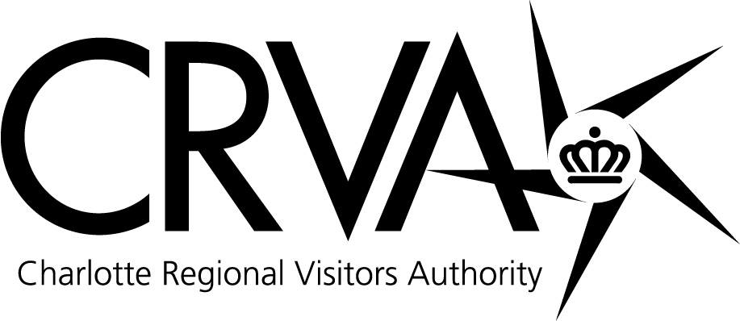

Charlotte Regional Visitors Authority
Board Meeting
Wednesday, November 10, 2010
8 AM – Room 201A/B – Charlotte Convention Center

Attending: Vi Lyles, Joe Hallow, Vinay Patel, Anthony Lindsey, Tom Sasser, Rai Glover, Paul Jamison, and Larry Huelsman. Attending via teleconference: Derick Close, Geoff Durboraw, and Mike McGuire. Absent: Caldwell Rose and Tom Manno.

Staff in Attendance: Tim Newman, Mike Crum, Winston Kelley, Larry Williams, Mike Butts, Gina Sheridan, Molly Hedrick, Ted Lewis, Lamont Holman, Jamie Faris, Bill McMillan, Kimberly Meesters, Laura Hall, Jorge Rodriguez, Brandy Richard, Mike Applegate, Lee Gaddis, Nick Biancofiore, Mariel Littrell and Debbie Aldridge.

Guests: Cameron Furr, CRVA Attorney from Grier Furr Crisp; Erik Spanberg from the Charlotte Business Journal; Sid Smith representing the Charlotte Area Hotel Association (CAHA); Karen Davis with NASCAR; Ron Kimble from the City of Charlotte and; Sean Scallan from the Marriott.

Meeting Called to Order: Vi Lyles, Vice Chair of the CRVA, called the meeting to order at 8:00 AM. On the phone at this time was Derick Close.

Approval of October 13, 2010 Meeting Minutes: Ms Lyles asked for a motion for approval to the CRVA minutes as submitted. There being no questions or comments, Ms. Glover made a motion to accept the minutes. The motion was seconded by Mr. Hallow. For: Lyles, Hallow, Patel, Sasser, Glover, Jamison, Huelsman, Close. Against: None.

NASCAR Hall of Fame Update: Mr. Newman noted that we have been through a difficult period but we are heading to a brighter time. (Mr. Lindsey joined the meeting at 8:05 AM.) Mr. Kelley shared what the promotional plans are and shared some recent encouraging results. These points will be shared with City Council November 22nd at a dinner meeting. The Board received a listing of upcoming promotions scheduled through the end of the year to help increase attendance and create an interest in attending for family fun. Mr. Kelley reviewed data collected on visitor statistics on the NHOF as well as attendance figures on other Hall of Fame venues. Staff has been monitoring expenses and tactical ideas and activities have been identified to tie in with key strategies. (Mr. Durboraw joined the meeting via teleconference at 8:10 AM.) A new Sales and Marketing Manager has been hired – Marylaurel Eberhart Wilks – a veteran motorsports executive and dedicated Charlotte civic leader. It was noted that the NASCAR office tower is not managed or owned by the City and the CRVA has no implications on the CRVA budget. Mr. Hallow suggested that it would be good to compare some other Hall of Fame attendance figures (football, country music, basketball) from 2007 to 2010.

Strategic Imperatives: Strategic Planning Update - Mr. Crum reported on the Strategic Planning process that half the CRVA staff participated in under the direction of Chuck Banford on November 1 and 2. Dr. Banford took the group through creating a frame around what will strategically drive the CRVA over the next three to five years. The management team is currently reviewing and revising the plan. A meeting has been scheduled for November 30th with the CRVA Strategic Planning Committee at which time Dr. Banford will visit with the Committee. Following that meeting there will be a session with the Board to review what has been developed with the plan being finalized by January 2011 prior to budget planning for FY12.

Amateur Sports Update - Through collaboration over the years with the Charlotte Sports Commission and the Mecklenburg County Parks and Recreation Department, the CRVA has gathered information regarding facility needs for amateur sports which may be incorporated into the CRVA strategic planning process. Mr. McMillan noted that the key point is how to maximize park and recreation facilities in order to drive tourism. Team sports (baseball, soccer, lacrosse, football and softball) are more lucrative than individual sports, and they impact hotel rooms around the city. Growth opportunities to consider are indoor, air conditioned basketball courts, soccer, baseball, football and lacrosse fields. With recent budget cuts, the CRVA’s ability to use funds to retain or book future business is reduced. Board members want amateur sports funding issues to be a part of the CRVA strategic plan in order to expand this business. Ms. Lyles thanked Larry Huelsman for encouraging the CRVA to look at this strategically and to consider ways to secure private and public funding. Ms. Lyles suggested that other models be viewed where government was not a major participant in developing facilities and see how that was structured.

Sales and Marketing: Visitor Statistics – Reporting in the absence of Mr. Helms, Mr. Crum noted that September occupancy continues to improve with Charlotte reporting a 12.75% occupancy rate vs. 6.7% for the US. RevPAR and ADR are growing as well. Among the twenty Charlotte properties from which the staff gathers information, transient, group and contract business has continued to grow consistently over the past eight months. Mr. Patel noted that transient business is looking better in September 2010 than it was in September 2007 which was one of the better years for the hotel industry. Mr. Patel requested that we start benchmarking our numbers compared to the 2007 numbers.

Sales Activities - Mr. Butts reported that last month was a good month with fifteen events booked definite for 18,000 room nights. A booking of note was the American College of Medical Genetics for March 2012 for the Convention Center. Lost business of note was the National School Supply and Equipment due to hotel rates/costs. Mr. Hallow noted that hotel rates are being sold for less in 2010 than they were in 2009; however, he is optimistic that rate follows demand and we are going in the right direction. The CIAA has confirmed for another three years in Charlotte from 2012-14. The TEAMS event in Charlotte was successful and garnered RFP’s for the sales team to work through for amateur sporting events. This past week Visit Charlotte hosted a Customer Advisory Board consisting of about sixteen customers from groups that come to Charlotte. The board members shared their recommendations for the City to attract conventions. Mr. Butts reviewed some of the recommendations, including capitalizing on the airport, which in the eyes of board members was one of Charlotte’s best assets. The board also noted the City’s need for a 1,000 to 1,200 room hotel.

Marketing Activities – Ms. Sheridan spoke on the current promotion, “’Tis the Season to Enjoy Charlotte’s Great Deals” with the goal of promoting a holiday getaway to generate traffic, brand awareness, encourage word of mouth advertising and driving qualified traffic to charlottesgotalot.com, highlighting NASCAR, shopping and football. The estimated reach of the campaign is 2.5 million consumer impressions. The ACC Championship Sweepstakes runs October 9-November 27 with 95% of registrants coming from outside the Charlotte DMA. A new “family” video was shared with the board. Ms. Lyles gave a special thanks to the team and staff that put together the CIAA noting the economic impact it has on the City.

Measures: September Financial Report – Mr. Williams stated that the balance sheet reflects the CRVA is in sound financial condition. The CRVA had a net deficit of $219,193 versus a budgeted surplus of $33,953 for the month of September. This net deficit is derived from the $8,333 food and beverage profit sharing with the Bobcats, the $258,522 deficit of the NASCAR Hall of Fame and the $30,995 surplus from Parking Operations. Visit Charlotte’s net expense of $686,000 puts them $121,000 ahead of budget for the month. The Convention Center had an operating deficit of $278,000. Bojangles’ Coliseum recorded an operating deficit of $131,000. Ovens Auditorium recorded an operating deficit of $34,000. At the Time Warner Cable Arena, expenses were over budget by $120,000 primarily event driven. During September, the NASCAR Hall of Fame had a net operating deficit of $259,000. Accrued (unpaid) royalty expense of $61,000 is included in the total expenses for the month. Fiscal year-to- date, the NASCAR Hall of Fame has an operating deficit of $449,000 which includes accrued royalty expense of $197,000. Actual expenses for the Airport division were under budget by approximately $5,000. CRVA Parking Operations had a net surplus of $31,000 for the month versus a budgeted surplus of $45,000. The Fund Balance Projection: The FY 2011 Fund Balance goal is $4 million and based on the projections at the end of September, staff believes they will meet the fiscal 2011 goal. A motion was made to accept the September Financial Report by Mr. Lindsey, seconded by Mr. Hallow. For: Lyles, Hallow, Lindsey, Patel, Glover, Sasser, Jamison, Huelsman, Durboraw and Close. Against: None. (Mr. McGuire joined the meeting via teleconference at 9:05 AM.)

FY 2010 Employment Diversity Report - Mr. Williams submitted the Employment Diversity Report as of June 30, 2010 which gives a breakdown of full-time employees by race and gender as well as a report by race, by division, by department. Data for fiscal 2009 was also presented for comparison. It was noted that most of the new hires have been for the NASCAR Hall of Fame division. Mr. Newman thanked Mr. Williams and the CRVA Diversity Team for their hard work.

Quarterly Communications Update: Ms. Hedrick gave a report showing the board what the CRVA does on a national level from a communications perspective featuring articles on Charlotte (entertainment and restaurants) which have appeared in magazines reaching millions of readers. The Communications Department courts travel writers like the sales team courts meeting planners. Ms. Hedrick showed a graph with monitored news impressions about Charlotte, noting what events triggered the news in each month. Regarding community relations, Ms. Hedrick reported that the CRVA will participate in the Carrousel Parade on Thanksgiving Day. The department was involved in arranging for the ACC football mascots to visit the Levine Center Children’s Hospital before the ACC Football Championship game. Ms. Hedrick stated that a group of representatives from City groups gets together every quarter to discuss what’s going on in Charlotte and everyone is on the same page working to get the news out.

Consent: Management Report – Mr. Newman gave kudos to the Convention Center and Visit Charlotte for the ASM Biomedical Research Conference for Minority Students being held for the first time here November 11-13, attributable to the Grand Ballroom and the Hall of Fame.

There being no further business, at 9:20 AM, Ms. Lyles asked for a motion to go into Executive Session under General Statute 143-318.11 (a)(5) to establish, or to instruct the CRVA’s staff, concerning the position to be taken by or on behalf of the CRVA in negotiating the amount of compensation and other material terms of an employment contract or proposed employment contract. Mr. Lindsey made the motion to move into Executive Session, seconded by Mr. Patel. For: Lyles, Hallow, Lindsey, Patel, Glover, Sasser, Jamison, Huelsman, Close, Durboraw and McGuire. Against: None.

The regular meeting was reconvened at 9:33 AM. There being no further business, the meeting was adjourned at 9:34 AM.

Geoff Durboraw, Secretary

