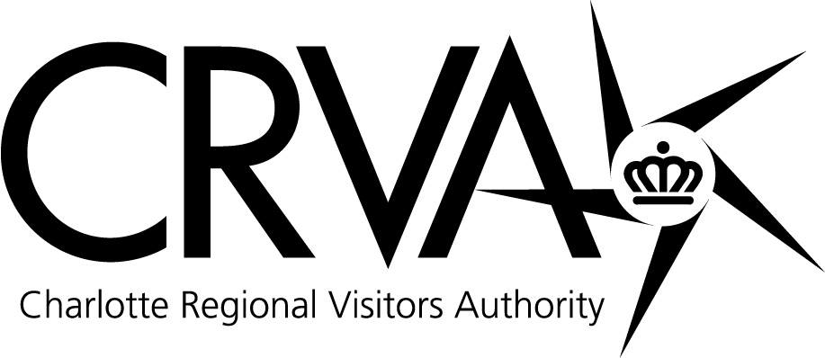

Charlotte Regional Visitors Authority
Board Meeting
Wednesday, September 08, 2010 – 8 AM
Charlotte Convention Center – Room 201 A/B

Attending: Derick Close, Vi Lyles, Joe Hallow, Geoff Durboraw, Vinay Patel, Tom Sasser, Tom Manno, Larry Huelsman, Caldwell Rose, Anthony Lindsey and Paul Jamison. Present via teleconference: Mike McGuire. Absent: Rai Glover.

Staff in Attendance: Tim Newman, Mike Crum, Jim Helms, Mike Butts, Gina Sheridan, Larry Williams, Ted Lewis, Bill McMillan, Molly Hedrick, Winston Kelley, Jorge Rodriguez, Laura Hall, Mike Riviello, Stephany Ghroke, Nick Biancofiore, Erin Icenhour, Lamont Holman, Jamie Faris, Joelle Lapsley and Debbie Aldridge.

Guests: Cameron Furr, CRVA Attorney from Grier Furr & Crisp; Ron Kimble from the City of Charlotte; Sid Smith from the Charlotte Area Hotel Association and Erik Spanberg from the Business Journal.

Meeting Called to Order: Chairman Close called the CRVA Board Meeting to order at 8:00 AM.

Approval of August 11, 2010 Meeting Minutes: Mr. Lindsey made a motion to approve the minutes of the August meeting. The motion was seconded by Mr. Hallow. For: Close, Lyles, Hallow, Durboraw, Patel, Sasser, Manno, Huelsman, Rose, Lindsey and Jamison. Against: None.

Strategic Imperatives: CIAA Renewal Update - Mr. Newman reviewed the CIAA renewal process. The CRVA was given until the end of August to submit the bid for renewal of the Tournament for 2012-2014. Mr. Newman stated that he feels we have met all the objectives of the CIAA Board and Commissioner. The bid is now being evaluated and it is expected that we will hear something back in the next few weeks and then begin the detailed negotiations. There should be an announcement no later than 2011. Mr. Newman noted that he feels we have a good relationship with the CIAA and he hopes to have more to announce to the board at the October meeting.

Airport Update – Mr. Newman apprised board members of the proposed changes of the taxi cabs at the airport. One issue Charlotte has had from the surveys of people visiting the city regards their taxi cab experience. The Airport is proposing changes in the types of taxi cab vehicles that operate at the airport. Council has authorized the Airport Authority to move forward with an RFP process for cab companies that meet the standards. The advertising relationship with the Airport Authority and the CRVA continues to be positive with both parties and there are good things on the horizon in terms of advertising opportunities. Since the Info Center has been unveiled, it is hosting 14,000 to 15,000 visitors a month. After the new retail concessionaire is finalized, probably next week, there are more things the CRVA plans to do. Among the top twenty-five airports, Charlotte is the lowest cost and the eighth busiest in the country.

Sales and Marketing: Visitor Statistics - Mr. Helms reported that the percentage change in Occupancy for July is at 20% for Charlotte versus the US which is at 7%. Charlotte ADR and RevPAR also exceeded the US for the month of July. July 2010 exceeds the 2009 measures in Occupancy, ADR and RevPAR which Mr. Helms contributes to the Girls Fast Pitch Softball event which booked 16,000 room nights. Year-to-date we are competitive with the “comp set” in occupancy for the month of July. Full service, limited service and Center City hotels are in the 60% range in occupancy for the month of July. Occupancy measures have remained consistent for the last six months in transient, group and contract travel. Looking ahead at the August numbers, the uptown cluster occupancy is up 15.2%; ADR is down ½%; and RevPAR is up 14%. Smith Travel has revised their numbers more positively with demand estimated to be up 6.6%; occupancy up 4.4%; ADR down about 1/10%; and Rev PAR up 4.3% for 2010. According to Smith Travel, room rate growth projector will determine the magnitude of the recovery. They are still leery of the ADR recovery equation. For 2011, they think demand will increase about 2.5%; occupancy about 1.4% and ADR about 3.9%.

Sales Activities – Mr. Butts reviewed sales activity noting a good booking month with 24 events and 19,000 room nights booked; Three of the bookings were for the Convention Center, 8 were for amateur sports, and 12 of the events were for 2010. A booking of note was the Thunder Road Marathon which is a good event for the uptown area. A lot of business booked was through the “Business Express” sales team, with three people focusing on smaller meetings. Visit Charlotte just hired a new person, Erin Isenhour, to fill one of those positions. Yesterday was the start of a FAM trip with representation within the international market from Canada and England including publicists and journalists. Building Component Manufacturers will be here for a convention later this month and will be building a house for Habitat for Humanity. Visit Charlotte and partners will be working to find meals, transportation, etc. to help with their efforts. The Visitor Center had 250 visitors this past Saturday in light of the opening of Amelie’s next door.

Marketing Activities – Each board member was given an informational piece that Convention Services puts together – a Charlotte Coupons leaflet with coupon offers from various restaurants and venues in the area. Board members were also given an employee discount card for the Delish eating establishments in the Convention Center (Buon Cibo, Einstein Brothers Bagels, Bojangles and Starbucks Coffee). The 2011 Visitor Guide is now being produced with ad sales for that publication closing next week. The Fiscal 2010 Annual Review is now out and can be viewed on CRVA.com in the “About Us” section. Going green, copies were not printed. The Annual Review has been sent to City Council and the Mayor for review. Mr. Newman noted that hotel bookings are up for the upcoming Race Week.

Measures: July Financial Report – Mr. Williams reported on the financial report for the month ending July 31st. The balance sheet reflects that we are in sound financial condition. The majority of the accounts receivable is due from the City to be reimbursed after the fiscal year financial audit is completed. The CRVA had a net surplus of $143,333 versus a budgeted surplus of $413,906 for the month of July. This net surplus is derived from the $8,333 food and beverage profit sharing with the Bobcats, the $90,196 surplus generated by the NASCAR Hall of Fame and from the $44,804 surplus from Parking Operations. Visit Charlotte’s net expense of $553,746 puts them $407,071 ahead of budget for the month. The Convention Center had an operating deficit of $422,000. Overall revenues were down from budget by 6% due mainly to short-term rental revenue not meeting expectations. Overall expenses came in very close to budget except for utilities which exceeded budget by $45,000. This increase in utilities is due mainly to the addition of the NASCAR Hall of Fame and the shared use of the boilers and chillers. After some history is gathered, a plan will be developed to come up with a reasonable allocation of these utility costs between the two facilities. Bojangles’ Coliseum recorded an operating deficit of $15,860. Ovens Auditorium recorded an operating deficit of $80,556. At the Time Warner Cable Arena, expenses were over budget by $56,289 which is primarily event driven. The net surplus for the NASCAR Hall of Fame for the month was $90,000. Actual expenses for the Airport division were under budget by approximately $7,000, primarily in the part-time salaries and related benefits line items for the Welcome Center. CRVA Parking Operations had a net surplus of $45,000 for the month versus a budgeted surplus of $40,000. Fund Balance Projection: The FY 2011 Fund Balance goal is $4 million and based on the projections at the end of July, it is believed we will meet or exceed the fiscal 2011 goal. Mr. Caldwell made a motion to accept the July Financial Report, seconded by Mr. Durboraw. For: Close, Lyles, Hallow, Durboraw, Patel, Sasser, Manno, Huelsman, Rose, McGuire, Lindsey and Jamison. Against: None.

Budget Amendment #1 for FY11- The CRVA Budget Committee met, reviewed and recommended approval of budget amendment #1 which transfers $40,000 from a rigging improvement capital project to the pipe and brine replacement capital project at Bojangles’ Coliseum. The net effect on the fund balance is zero. This transfer of funds will allow Bojangles’ Coliseum the opportunity to book more ice shows. Mr. Lindsey made a motion to approve the budget amendment. The motion was seconded by Ms. Lyles. For: Close, Lyles, Hallow, Durboraw, Patel, Sasser, Manno, Huelsman, Rose, McGuire, Lindsey and Jamison. Against: None.

FY10 Goal Attainment – Mr. Helms reviewed Global CRVA Goals for FY2010 as well as divisional and joint goals for the organization. With weak economic conditions, the financial goals were not met; however, 75% of the global goals were attained and division goal attainment ranged from 50% to 83%. A summary of divisional organization goals was included in the CRVA board booklet for review with notes on which goals were attained and which goals were not met. Ms. Lyles noted that in light of the economic conditions, this was a great report with the organizations meeting global and customer service goals. Looking forward to the revamping of the strategic planning goals, the board members will have the opportunity to see what is appropriate on a divisional level and what is most important globally for the organizations to be successful. In terms of the process, there will be a retreat to talk about what goals are important globally and to build the divisional goals. A facilitator will be used for the strategic planning process and at the October meeting a schedule will be discussed. The strategic planning process will cover a five year plan.

Consent: Management Reports - Mr. Crum gave his comments on the management reports. Mr. Butts reviewed sales activities for the last two months as shown on page 44 of the board packets. The Convention Center office expansion and food court has been completed. Staff is in the process of moving their offices into that location. The new offices will house the Human Resources Department, some of the NASCAR Hall of Fame employees and the marketing/communications offices of the Visit Charlotte staff. Event volume is down for Bojangles’ Coliseum and Ovens Auditorium for the summer months. Staff has been working on operations projects. At Time Warner Cable Arena, the roof project repair is underway with the intention of completion by the first Bobcats game in November. Customer service ratings continue to be very positive at the NHOF. There is a lot of programming taking place outside of the Hall. Finally, in terms of communications, there has been a wide spectrum of travel writers and publications that have shown an interest in Charlotte. Mr. Caldwell noted that signage needs to improve at the NHOF parking garage. People are having problems understanding the wayfinding notations. (Mr. McGuire disconnected from the teleconference call.)

Executive Session: A request was made by Chairman Close for a motion to move into Executive Session at 8:50 AM, under North Carolina General Statute Sections 143.318.11 (4) and (5) to discuss matters relating to the location or expansion of business in the area served by the CRVA and to establish, or to instruct the CRVA’s staff, concerning the position to be taken by or on behalf of the CRVA in negotiating the amount of compensation and other material terms of an employment contract or proposed employment contract. The motion was made by Ms. Lyles and was seconded by Mr. Rose. For: Close, Lyles, Hallow, Durboraw, Patel, Sasser, Manno, Huelsman, Rose, Lindsey and Jamison. Against: None.

The regular meeting was reconvened at 9:22 AM. There being no further business, the meeting was adjourned at 9:23AM.

Geoff Durboraw
Secretary

