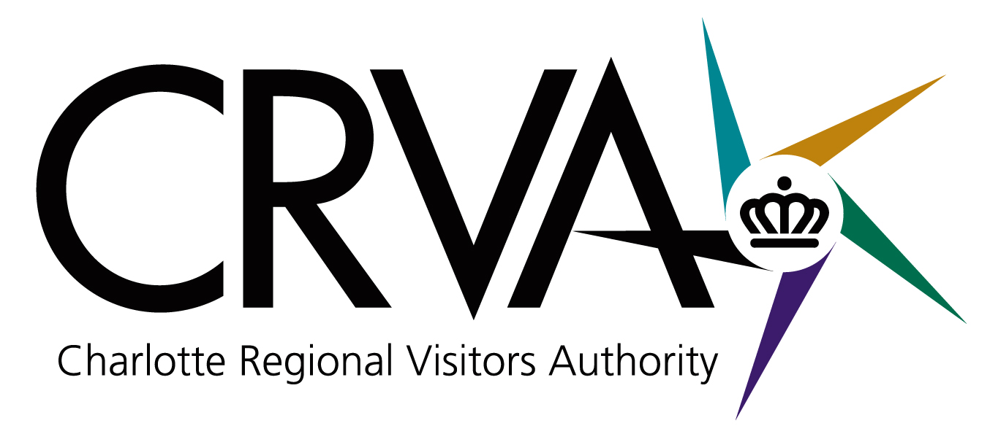
AMENDED

Charlotte Regional Visitors Authority
Board Meeting
Wednesday, January 14, 2009 – 8 AM
Charlotte Convention Center – Room 201 A/B

Board Members in Attendance: Ravi Patel, Vi Lyles, Geoff Durboraw, John Sweeney, Tom Sasser, Derick Close, Anthony Lindsey, Caldwell Rose, Joe Hallow, Tina Whitley. Attending via teleconference: Jim Nash. Absent: Anthony Fox and Rai Glover.

Staff in Attendance: Tim Newman, Mike Crum, Larry Williams, Jim Helms, Mike Butts, Gina Sheridan, Molly Hedrick, Ted Lewis, Eric Scott, Carole Thompson, Jeff Mann, Mike Applegate, Karen Ehlinger, Jorge Rodriguez, Nick Biancofiore, Ereka Brim, Susan Schwint, Brandy Richard, Donna Carpenter, Mariel Littrell and Debbie Aldridge.

Others in Attendance: Cameron Furr, CRVA Attorney from Grier Furr and Crisp; Ron Kimble from the City of Charlotte; Bill McMillan representing the Visitors Advisory Committee (VAC); Ann Marie O’Keefe from Channel 9 News; Jeff Wise from the US National Whitewater Park; Sid Smith representing the Charlotte Area Hotel Association (CAHA); and Lloyd Scheer.

Meeting Called to Order: Chairman Nash called the meeting to order at 8:00 AM.

Approval of December 10, 2008 Meeting Minutes: Mr. Patel made a motion to accept the minutes as submitted for the December 10, 2008 board meeting. The motion was seconded by Mr. Lindsey. For: Nash, Patel, Lyles, Durboraw, Sasser, Close, Lindsey, and Rose. Against: None. (Mr. Hallow and Ms. Whitley arrived at 8:03 AM.)

Strategic Imperatives: Review of December VAC Meeting - Mr. Newman noted that the December VAC meeting was very successful. Participating in the meeting was Lee Keesler of the Arts and Science Council, Michael Smith of the Center City Partnership, Bob Morgan of the Charlotte Chamber of Commerce, and Jeff Beaver of the Charlotte Regional Sports Commission. The group emphasized the importance of hospitality on the economy and the importance of all partners working together. Mr. McMillan, Chairman of the VAC, spoke on the Committee meeting stressing the importance of how we are approaching difficult times in 2009 and what we can do together to get through these times. The committee suggests leveraging partnerships and showing optimism since so much of what we do is impacted on how we look at things. Mr. Lindsey commented that this was his first VAC meeting and noted that he was very impressed with how well our CRVA CEO, Tim Newman, knows his product and how to present it. He also noted that it was interesting to hear different perspectives on the market outlook and how it can be woven together and the strength of the Committee. Mr. Newman thanked Mr. McMillan for his continued leadership on the VAC.

Report of January Strategic Planning Committee- Chairman of the CRVA Strategic Planning Committee, Derick Close, reported on the January 6th meeting held to look at the local economic condition affecting the CRVA organizations. (Mr. Sweeney arrived at 8:15 AM). The Committee viewed the CRVA organization budget projections. All the budget reports reflect a continued downturn in the local and regional economy. On a positive note, Mr. Butts was called upon to speak on the recent American Bus Association Convention just held in Charlotte with 58,000 roomnights sold and 30 events. Mr. Butts also noted the good events held in December with the Meineke Bowl, Career of Technical Education and an upcoming Cheerleading event being held at the Charlotte Convention Center this weekend. Mr. Close noted that the City’s Director of Finance will be making a report to the Board in February on the projection of tax collections and the CRVA Strategic Planning Committee will delay any action until after that report from the City is made. This will then kick off the planning of the 2010 budget. Mr. Nash thanked the Committee and staff for their extensive work on strategic planning.

Sales and Marketing: Visitor Statistics – Mr. Helms reviewed Visitor Statistics showing that Occupancy is down 17% for the month of November 2008 compared to the U.S. and down 8.2% year-to-date (YTD). Charlotte is up in ADR, but down in RevPAR for the month as well as YTD. 2008 is down in all areas compared to 2007. Reports show that leisure travel is down. Comp set and the U.S are all in the same ball park for Occupancy, close in ADR and RevPAR. Mr. Helms noted that ADR is up .2% for the uptown hotels. Things have not changed much as far as the global goals since last month.

Sales Activities - Mr. Butts stated that December was an excellent booking month with a 58,000 room night production and 30 events. Twelve are Convention Center related with over 9 million square feet of the CCC (Charlotte Convention Center) booked. A booking of note is the International Association of Dental Research for March 2014. A “lost” booking of note was the American Pharmacist’s Association for March 2016 due to space requirements. There was a cancellation of the Pampered Chefs for 2010 due to the current economic situation. Staff is awaiting word of confirmation from the American Farm Bureau for 2014. Mr. Butts showed an example of the “bacon sheet” used to manage accounts by the sales staff. Some of these accounts are new and some are repeat business. It was also noted that the opening of the NHOF will bring business to Charlotte. Mr. Lindsey asked if staff had ever done a comparative analysis with the comp set groups to see why we lose business. Mr. Newman noted that sometimes Charlotte is just not the right fit. Mr. Rose asked for a report at next month’s meeting with the top five reasons for the loss of business to other cities.

There was a presentation to the Board on the American Bus Association Marketplace’s (ABA) visit, activities, and their contributions to local charities. Mr. Butts thanked and complimented staff for their hard work on this international event. The sales team will now be busy following up noting that there have already been some bookings from hosting this event. Ms. Hedrick reported on the communications side for the ABA with the Charlotte Observer, FOX News, and News 14 Carolina all reporting and participating in the activities.

Marketing Activities - Mrs. Sheridan explained how much extensive work they put into supporting a group when it comes to Charlotte, showing the logo that staff designed for the event which promoted the event while extending the City’s brand. Marketing pieces were developed for the event such as the “Dine-Around Guide” and marketing pieces were shared from the “Breast Friends” event. Mrs. Sheridan showed a slide presentation of the new ads launched in January. There was a 60 foot booth at the ABA event which also promoted the region’s brand. The next five ads in the series of Charlotte’s Got A Lot were shown: “Splurge A Lot,” “Captivate Charlotte,” “Unwind A Lot,” “Cherish A Lot,” and “Discover A Lot.” An ad was showed that was placed in the NC Official Travel Guide where area partners are able to participate by placing affordable ads.

Measures: November Financial Report – The November balance sheet reflects that the CRVA is in sound financial condition. Worthy of note on the balance sheet is that invested cash has increased by $1 million due to collections of accounts receivable, primarily made up of reimbursements due from the City of Charlotte for operating subsidies and marketing distributions. The CRVA had a net surplus of $8,333 resulting from the Food and Beverage profit sharing agreement with the Bobcats. Visit Charlotte is ahead of budget by $273,000 for the month due to a timing difference as to when marketing/advertising and business development expenses hit. The Convention Center had a gross operating deficit of $259,000 versus a budgeted deficit of $380,000 which puts them $121,000 ahead of budget. The Ovens Auditorium /Bojangles’ Coliseum Arena Complex recorded a gross operating surplus of $22,000 versus a budget surplus of $23,000. At the Time Warner Cable Arena, expenses were over budget by $15,000, primarily due to repairs and maintenance costs. Actual expenses were $77,000 versus a budget of $149,000 for the NASCAR HOF due primarily to timing differences as to when advertising and promotion expenses will occur. And finally, expenses for the Airport division were under budget by $3,000. Fund Balance Projection: The CRVA expects to maintain the fund balance projection of $4 million for the year ending June 30, 2009.
At the request of Chairman Nash, Mr. Williams apprised the Board that the CRVA invests its money with the State Treasury Office receiving a 2% interest. By law, the CRVA is limited as to what it is allowed to invest in. (Mr. Close left the meeting at 9:11 AM.) Mr. Patel made a motion to accept the November 2008 Financial Statement which was seconded by Mr. Sasser. For: Nash, Lyles, Patel, Durboraw, Sweeney, Sasser, Lindsey, Rose, Hallow and Whitley. Against: None.

Updated FY2009 Projections - Mr. Williams presented the Budgeted and Projected Variances for each CRVA organization which was reviewed in a joint meeting of the CRVA Strategic Planning Committee and the CRVA Budget Committee to show where each organization is as of January 6, 2009. Any capital improvement cutbacks for projected savings will not affect modifications to the physical plant at Bojangles’ Coliseum. The handicapped modifications to be made at Ovens Auditorium will still be made. Funds for the Department of Justice modifications are in the City fund now.

Budget Committee Recommendations/Parking Operations Budget - Chairman of the Budget Committee, Mr. Patel, noted that the Committee met to review Budget Amendment 2 regarding the CRVA managing the Hall of Fame parking and the NASCAR Office Building parking. This could prove to be a money-maker for the CRVA once the NHOF opens in 2010. Staff has developed a budget; however, there is an expected deficit for the beginning operations in the amount of $199,861 as of June 2009. There was not a quorum at the Budget Committee meeting; however, half of the Committee believes this amendment should be approved. Mr. Crum discussed why the CRVA should manage the parking operations at the NHOF deck: to insure good customer service, to take advantage of economies of scale with other CRVA venue parking areas, and for a possible revenue stream. There was a discussion as to why a third party was not considered to run the parking deck. There will initially be a deficit and it is felt that a third party would not be interested at this time. There are plans to hire an experienced parking manager who will handle the management of the NHOF parking deck as well as the parking operations at Bojangles’ Coliseum and Ovens Auditorium. (Mr. Sweeney left the meeting at 9:25 AM.) Mr. Patel made a motion to approve the Budget Amendment 2 as presented. The motion was seconded by Mr. Hallow. For: Nash, Patel, Durboraw, Sasser, Lindsey, Rose, Hallow and Whitley. Mrs. Lyles had left the meeting temporarily and was not present for the vote. Against: None.

Consent Management Report: Mr. Newman wanted the Board members to take note of the letter written to Dan Morrill of the Historic Landmarks Commission wherein the CRVA adopted a neutral stance as to the designation of historic landmark status to the exterior of the Bojangles’ Coliseum. To date, staff is not aware of the Landmark Commission approaching the City on this issue.

Executive Session: Mr. Rose made a motion to move into Executive Session at 9:35 AM under North Carolina Statute Section 143.318.11(6) to consider performance of an employee. For: Nash, Patel, Durboraw, Sasser, Lindsey, Rose, Hallow, Lyles and Whitley. Against: None.

The regular session of the CRVA board meeting was reconvened at 10:03AM. Ms. Lyles made a motion asking the Compensation Committee to develop some guidelines for performance reviews and to accept the report presented by the Reznick Group. For: Nash, Patel, Durboraw, Sasser, Lindsey, Rose, Hallow, Lyles and Whitley. Against: None. There being no further business, the meeting was adjourned at 10:05 AM.

Vi Lyles
Secretary

